2.4.2 What a Wonderful Christmas!

Suggested Activities

Level: | S1
Materials: | - Activity Sheet (p.70), which contains an incomplete poem What a Wonderful Christmas!
Objectives: | Language-arts-related  - Using the target language pattern to continue a poem based on the given theme  Language-related  - Understanding the use of the conditional structure “If ______, ____ will ______” to express possible future situations  - Understanding the use of the suffix “-ful” to form adjectives  Phonics-related  - Understanding how the suffix “-ful” is a syllable in its own right  - Identifying words that share the same rime with the suffix “-ful”
Summary of the activities: | Students read a poem entitled What a Wonderful Christmas! and complete four stanzas with adjectives that end with the suffix “-ful”. They then compose two more stanzas based on the structure used in the other four stanzas.

Sharing learning intentions
Step 1 | Introduce the objectives of the activities.
Introducing the subject
Step 2 | Write the word “Christmas” on the blackboard and ask Ss to share what they want to happen for a happy, exciting or wonderful Christmas. Note down Ss’ ideas.
Focusing on the target language structure
Step 3 | Pick a few ideas from Ss’ contributions and rewrite them in the following pattern:  If _________________, _____ will _______________.  (e.g. If I have a party with my friends, that will be wonderful.)
Step 4 | Invite Ss to explain what meaning the “If _______, _____ will _______” structure expresses and the form that the verbs take. Provide feedback whenever necessary.

Focusing on phonics
Step 5 | Draw Ss’ attention to the adjective “wonderful”. Check if Ss know what the stem is (i.e. wonder) and how the suffix (i.e. -ful) changes the part of speech of the word (i.e. from a noun to an adjective). Have Ss indicate where the syllable markers and the stress marker should be put (i.e. “’won/der/ful”) to raise their awareness that the suffix is an unstressed syllable in its own right.
Step 6 | Have Ss suggest other adjectives ending in “-ful” which can be used to describe Christmas. Write Ss’ suggestions on the blackboard.
Practising the target language structure
Step 7 | Tell Ss to form groups of four. Give out the Activity Sheet on p.70, which includes the poem What a Wonderful Christmas!. Explain that the poem consists of sentences written in the pattern introduced in Step 3. Go through what Ss are expected to do in this activity. Ask Ss to complete Stanzas 1, 2, 3 and 6 using adjectives ending in “-ful”. Encourage Ss to use their own ideas for Stanzas 4 & 5.
Step 8 | Invite Ss to read out their poems after they have finished. Check if the adjectives provided by Ss are formed, spelt, used and pronounced correctly.
Reviewing progress
Step 9 | Guide Ss to reflect on what they have learnt, with reference to the objectives of the activities.

Activity Sheet
Look at the pictures in the thought bubbles and complete Stanzas 1, 2, 3 and 6 of the poem, using words ending in “-ful”. Then use your own ideas and write Stanzas 4 and 5.




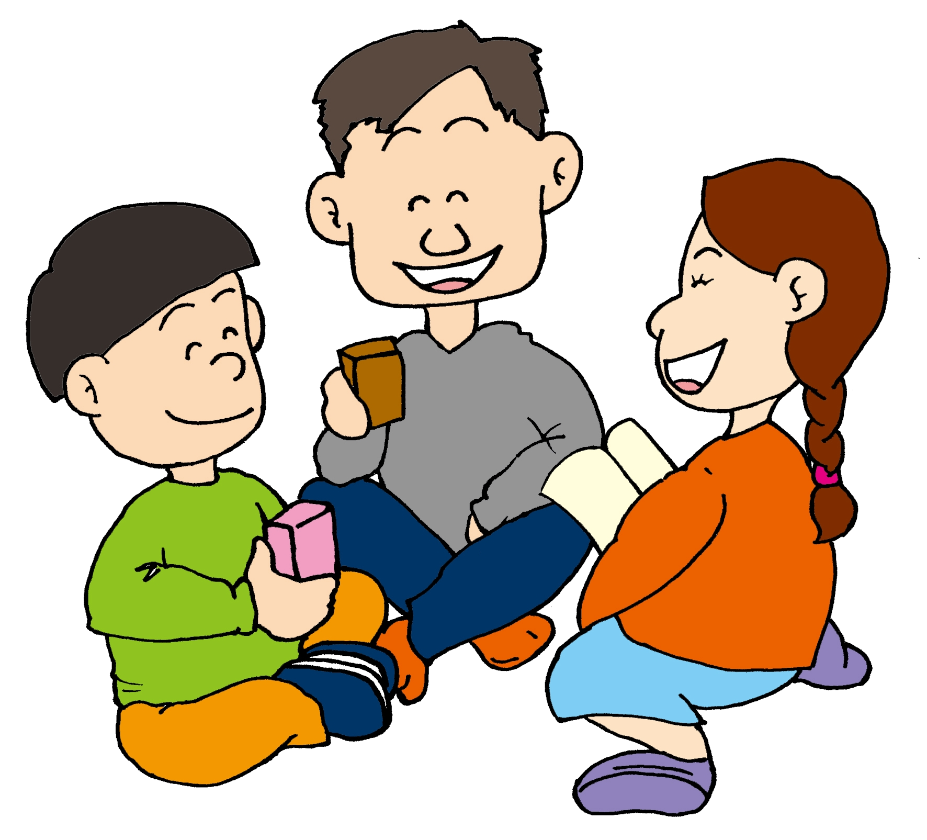
Stanza 1
If all my friends
Come to my party,
I will be _________.
Stanza 2
If they can get an iphone
For the lucky draw,
That will be ________.
Stanza 3
If they can roast a turkey
For the Christmas feast,
I will be _______.
Stanza 6
But if nobody comes to my party
On the big day,
I will feel _______.
Stanza 4
If _________________
__________________,
________________.
Stanza 5
If _________________
__________________,
________________.

Suggested Answers
Look at the pictures in the thought bubbles and complete Stanzas 1, 2, 3 and 6 of the poem, using words ending in “-ful”. Then use your own ideas and write Stanzas 4 and 5.

Stanza 1
If all my friends
Come to my party,
I will be grateful.
Stanza 6
But if nobody comes to my party
On the big day,
I will feel awful.
Stanza 3
If they can roast a turkey
For the Christmas feast,
I will be cheerful.
Stanza 4
If they can decorate my sitting room
With a Christmas tree,
That will be beautiful.
________________.
Stanza 5
If we can all sing Christmas carols
After the feast,
That will be joyful.
Stanza 2
If they can get an iphone
For the lucky draw,
That will be wonderful.

